Lab manual 9

Name: Syed Muhammad Hassaan.

Roll no: 460991

Lab task.

Task 1:

1. #include<iostream>
2. using namespace std;
3. int main(){
4. int numbers[3][3];
5. int suml,sumr;
6. for(int i=0; i<3; i++){
7. for(int j=0; j<3; j++){
8. cout<<"Enter Value for Element "<<j<<" of "<<i<<" row: ";
9. cin>>numbers[i][j];
10. }
11. }
12. for(int i=0; i<3; i++){
13. cout<<endl;
14. for(int j=0; j<3; j++){
15. cout<<numbers[i][j]<<" ";
16. }
17. }
18. suml=numbers[0][0]+numbers[1][1]+numbers[2][2];
19. sumr=numbers[2][0]+numbers[1][1]+numbers[0][2];
20. cout<<endl<<endl;
21. cout<<"Sum for Left Diagonal is: "<<suml<<endl;
22. cout<<"Sum for Right Diagonal is: "<<sumr<<endl;
23. }
24. 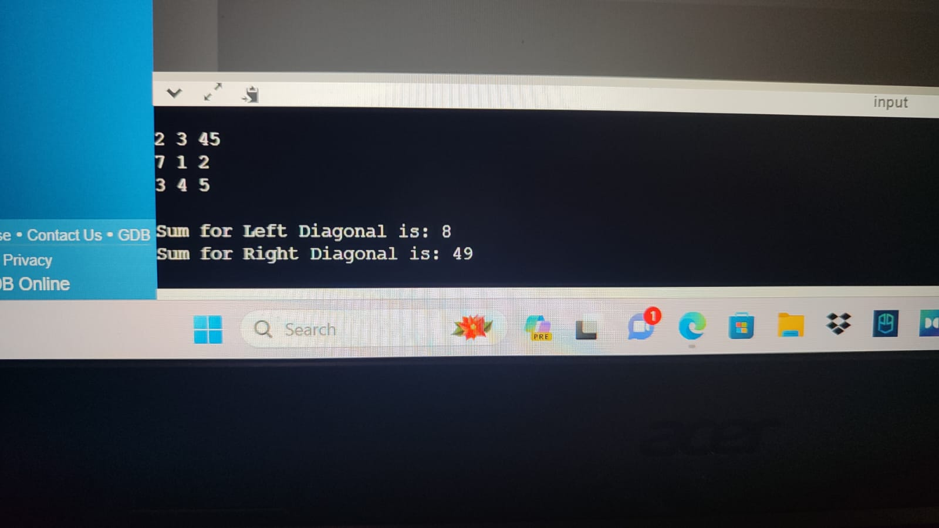

Task 2:

1. #include<iostream>
2. using namespace std;
3. int main(){
4. int x1[3][3], x2[3][3], sum[3][3];
5. int i, j;
6. cout<<"Enter the Values for Array 1: "<<endl;
7. for(i=0; i<3; i++){
8. for(j=0; j<3; j++){
9. cout<<"Enter Value for Element "<<j<<" of "<<i<<" row: ";
10. cin>>x1[i][j];
11. }
12. }
13. cout<<endl<<"Array 1 Filled! Now Input Array 2: "<<endl;
14. for(i=0; i<3; i++){
15. for(j=0; j<3; j++){
16. cout<<"Enter Value for Element "<<j<<" of "<<i<<" row: ";
17. cin>>x2[i][j];
18. }
19. }
20. for(i=0; i<3; i++){
21. for(j=0; j<3; j++){
22. sum[i][j]=x1[i][j]+x2[i][j];
23. }
24. }
25. cout<<endl<<"The sum for both Arrays is: "<<endl;
26. for(i=0; i<3; i++){
27. for(j=0; j<3; j++){
28. cout<<sum[i][j]<<" ";
29. }
30. cout<<endl;
31. }
32. }
33. 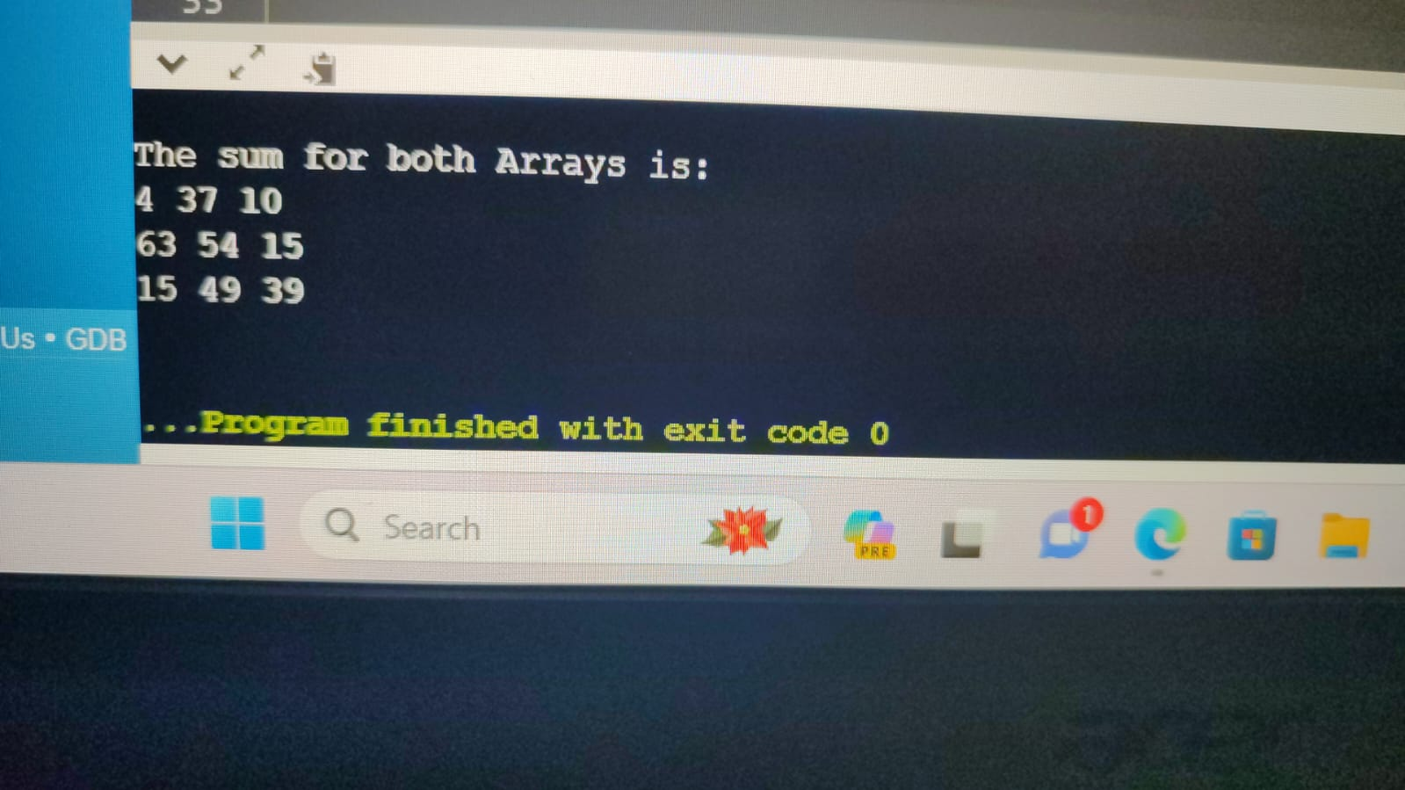

Task 3:

1. #include<iostream>
2. using namespace std;
3. int main(){
4. int arr1[3][3], transpose[3][3];
5. int i,j;
6. for(i=0; i<3; i++){
7. for(j=0; j<3; j++){
8. cout<<"Enter Value for Element "<<j<<" of "<<i<<" row: ";
9. cin>>arr1[i][j];
10. }
11. }
12. for(int i=0; i<3; i++){
13. cout<<endl;
14. for(int j=0; j<3; j++){
15. cout<<arr1[i][j]<<" ";
16. }
17. }
18. cout<<endl;
19. for(i=0; i<3; i++){
20. for(j=0; j<3; j++){
21. transpose[j][i]=arr1[i][j];
22. }
23. }
24. cout<<endl<<"Transpose of Given Array is: "<<endl;
25. for(int i=0; i<3; i++){
26. cout<<endl;
27. for(int j=0; j<3; j++){
28. cout<<transpose[i][j]<<" ";
29. }
30. }
31. }
32. 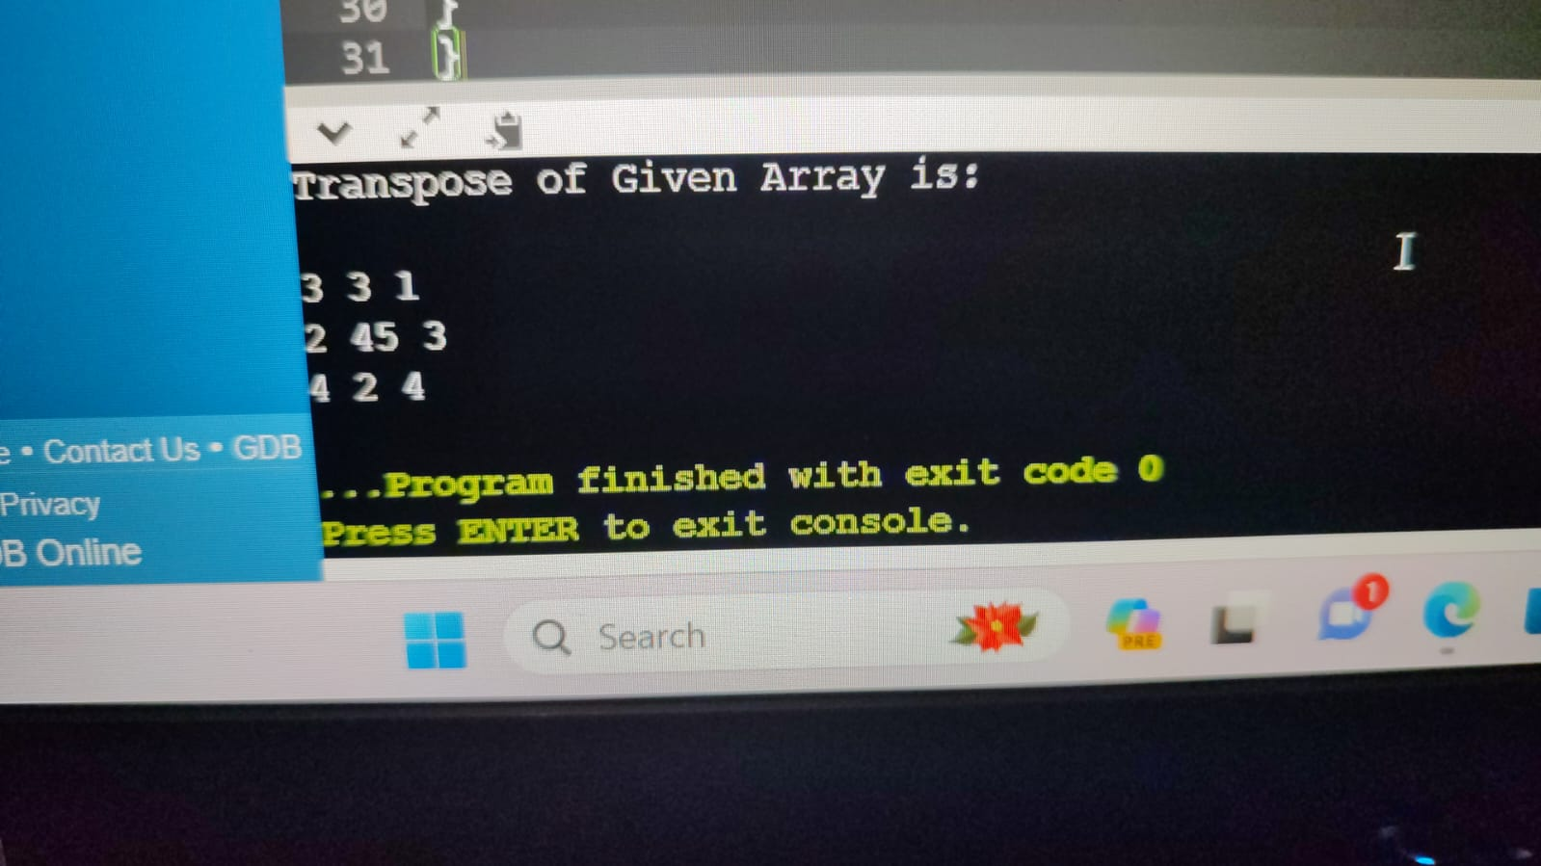

Task 4:

1. #include <iostream>
2. using namespace std;
3. int main(){
4. int x1[3][3], x2[3][3], multiple[3][3];
5. int i, j;
6. cout<<"Enter the Values for Array 1: "<<endl;
7. for(i=0; i<3; i++){
8. for(j=0; j<3; j++){
9. cout<<"Enter Value for Element "<<j<<" of "<<i<<" row: ";
10. cin>>x1[i][j];
11. }
12. }
13. cout<<endl<<"Array 1 Filled! Now Input Array 2: "<<endl;
14. for(i=0; i<3; i++){
15. for(j=0; j<3; j++){
16. cout<<"Enter Value for Element "<<j<<" of "<<i<<" row: ";
17. cin>>x2[i][j];
18. }
19. }
20. for ( i = 0; i < 3; i++) {
21. for ( j = 0; j < 3; j++) {
22. multiple[i][j] = 0;
23. for (int k = 0; k < 3; ++k) {
24. multiple[i][j] += x1[i][k] \* x2[k][j];
25. }
26. }
27. }
28. cout<<endl<<"Multiple of Given Array is: "<<endl;
29. for(int i=0; i<3; i++){
30. cout<<endl;
31. for(int j=0; j<3; j++){
32. cout<<multiple[i][j]<<" ";
33. }
34. }
35. }
36. 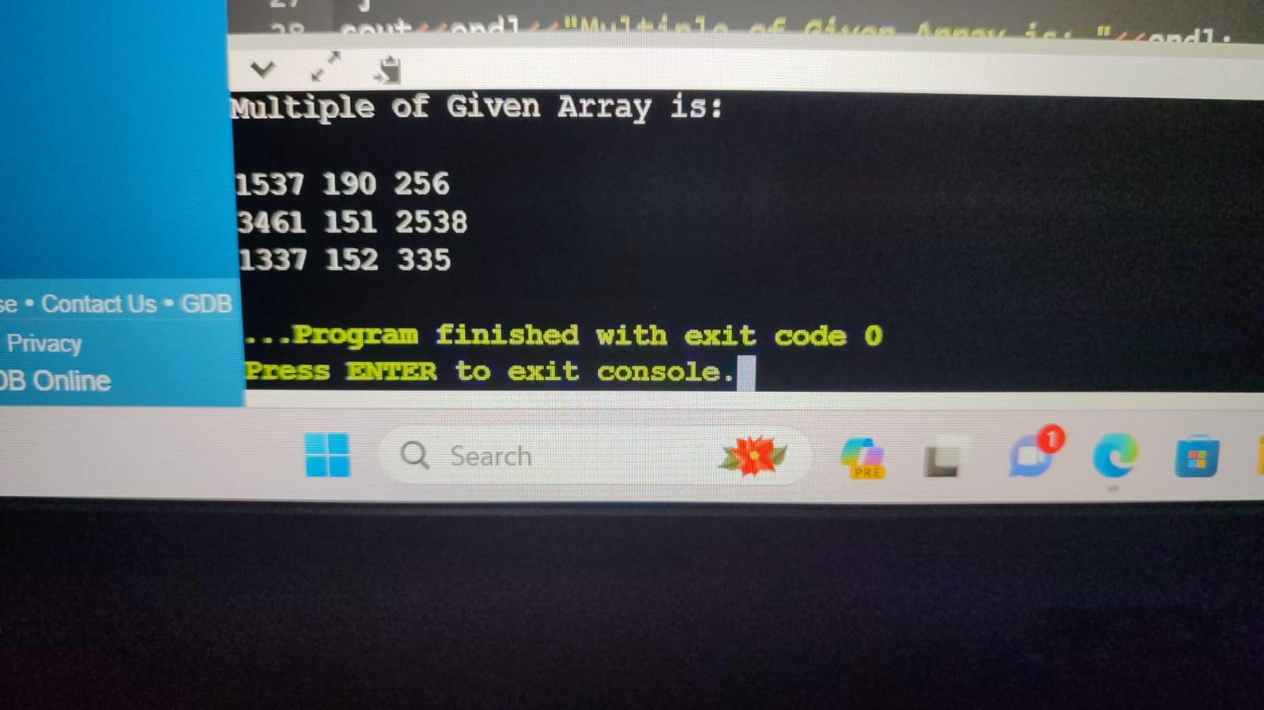

Task 5:

1. #include <iostream>
2. using namespace std;
3. void multiplication(int number, int multiplier = 1) {
4. if (multiplier <= 10) {
5. int result = number \* multiplier;
6. cout << number << " x " << multiplier << " = " << result << endl;
7. multiplication(number, multiplier + 1);
8. }
9. }
10. int main() {
11. multiplication(15);
12. return 0;
13. }
14. 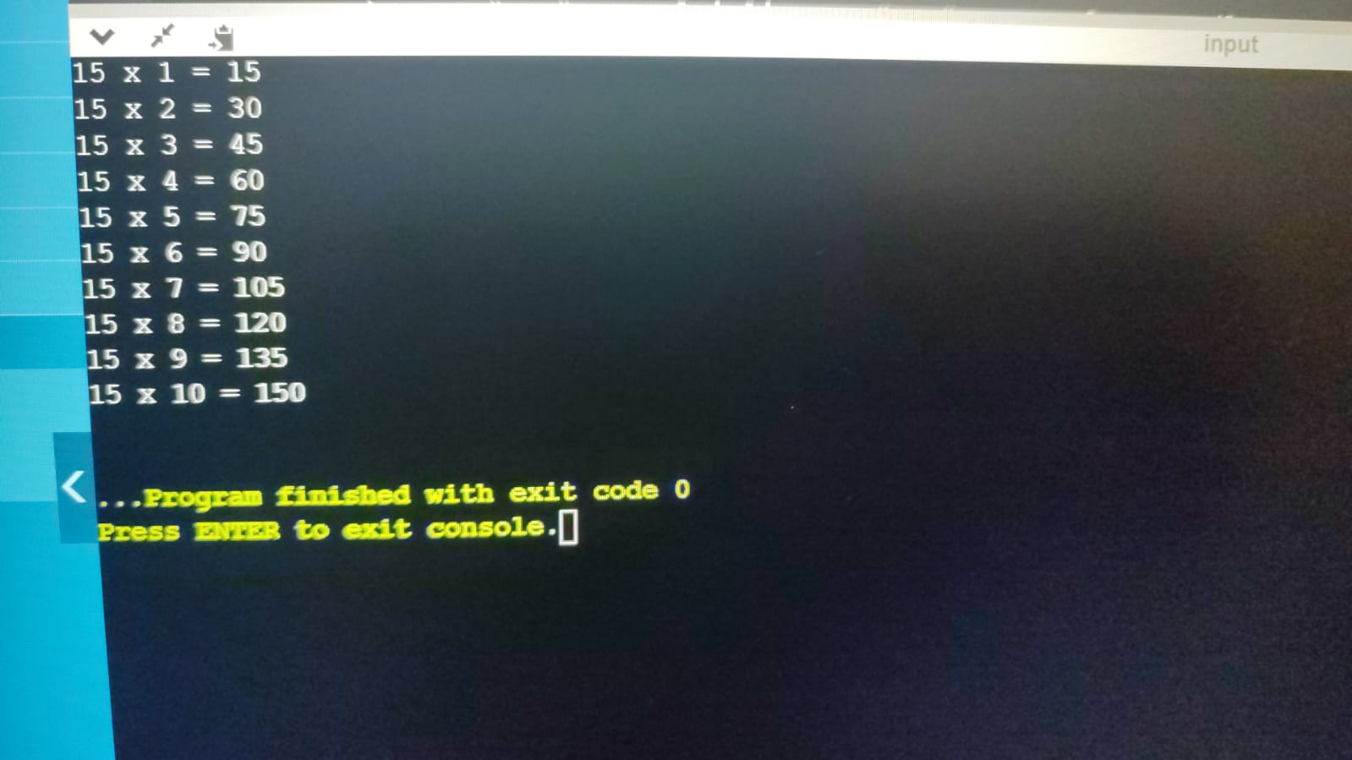

Home tasks:

Task 1:

1. #include <iostream>
2. using namespace std;
3. int main() {
4. float matrix[3][3];
5. cout << "Enter the elements of the 3x3 matrix:" << endl;
6. for (int i = 0; i < 3; ++i)
7. for (int j = 0; j < 3; ++j)
8. cin >> matrix[i][j];
9. cout << "The entered matrix is:" << endl;
10. for (int i = 0; i < 3; ++i) {
11. for (int j = 0; j < 3; ++j)
12. cout << matrix[i][j] << " ";
13. cout << endl;
14. }
15. float det = matrix[0][0] \* (matrix[1][1] \* matrix[2][2] - matrix[2][1] \* matrix[1][2]) -
16. matrix[0][1] \* (matrix[1][0] \* matrix[2][2] - matrix[2][0] \* matrix[1][2]) +
17. matrix[0][2] \* (matrix[1][0] \* matrix[2][1] - matrix[2][0] \* matrix[1][1]);
18. if (det == 0) {
19. cout << "The matrix is singular and cannot be inverted." << endl;
20. }
21. else{
23. float adj[3][3];
24. for (int i = 0; i < 3; ++i)
25. for (int j = 0; j < 3; ++j)
26. adj[i][j] = (matrix[(j + 1) % 3][(i + 1) % 3] \* matrix[(j + 2) % 3][(i + 2) % 3] -
27. matrix[(j + 1) % 3][(i + 2) % 3] \* matrix[(j + 2) % 3][(i + 1) % 3]);
28. float inv[3][3];
29. for (int i = 0; i < 3; ++i)
30. for (int j = 0; j < 3; ++j)
31. inv[i][j] = adj[i][j] / det;
32. cout << "The inverse of the matrix is:" << endl;
33. for (int i = 0; i < 3; ++i) {
34. for (int j = 0; j < 3; ++j)
35. cout << inv[i][j] << " ";
36. cout << endl;
37. }
38. }
39. return 0;
40. }
41. 